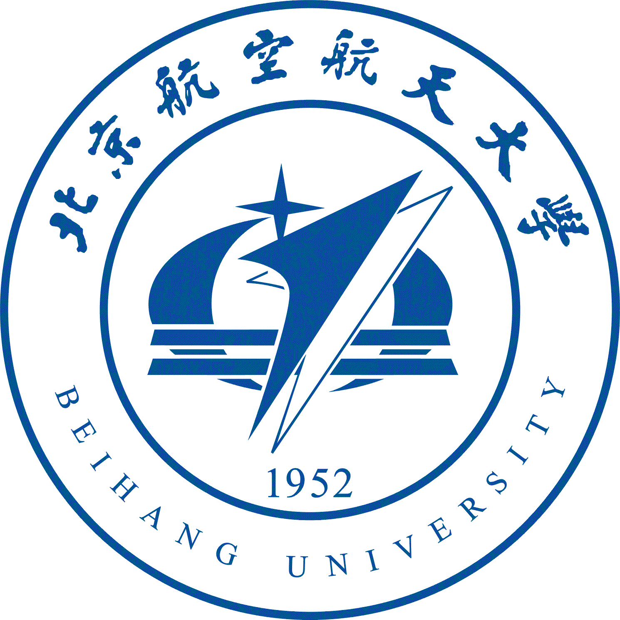
Workshop of Digital Innovation for Surgery Planning, Simulation and Treatment
The digital innovation in surgery presents a trend of precise, minimally invasive, and personalized features. This workshop aims to address the challenges by gathering, training and connecting the Early Career Researchers (ECRs) from different disciplines for better understanding of the complexity and contexts related to surgery technology and working together to develop impactful research projects, facilitated through the training from mentors and new joint research. The workshop will provide an excellent platform for both UK and Chinese ECRs to expand their research and stimulate collaboration on research and development, technology transfer and commercialization between UK and China.
Under the Researcher Links scheme (offered within the Newton Fund), Beihang University will be holding the workshop on the above theme in Liaoning Hotel Beijing on 16-18 October 2019. The workshop is being coordinated by Dr. Xiaosong Yang and Prof. Junjun Pan, and will have contributions from other leading researchers. We are now inviting ECRs from the UK or China to apply to attend this workshop. All travel and accommodation expenses will be covered by the Newton Fund Researcher Links programme. The application form, with more details on the initiative, is attached and should be sent to xyang@bournemouth.ac.uk by an email titled “Researcher Links Workshop” before the deadline of 15 July.
ACKNOWLEDGEMENT
This workshop was supported by a Researcher Links grant, ID 2018-RLWK10-10256, under the UK–China Research and Innovation Partnership. The grant is funded by the UK Department for Business, Energy and Industrial Strategy and National Natural Science Foundation of China and delivered by the British Council. For further information, please visit www.newtonfund.ac.uk.
ABOUT THE NEWTON FUND
The Newton Fund builds research and innovation partnerships with 17 active partner countries to support their economic development and social welfare, and to develop their research and innovation capacity for long-term sustainable growth. It has a total UK Government investment of £735 million up until 2021, with matched resources from the partner countries. The Newton Fund is managed by the UK Department for Business, Energy and Industrial Strategy (BEIS), and delivered through seven UK delivery partners, which includes UK Research and Innovation (comprising the seven research councils and Innovate UK), the UK Academies, the British Council and the Met Office. For further information visit the Newton Fund website (www.newtonfund.ac.uk) and follow via Twitter: @NewtonFund.

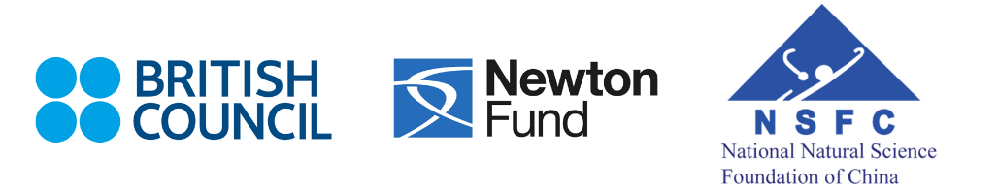
Supported by

Research Links Application Form

Workshop Title: Digital Innovation for Surgery Planning, Simulation and Treatment
UK Principal Coordinator: Dr. Xiaosong Yang, National Centre for Computer Animation, Bournemouth University, United Kingdom
Partner Country Principal Coordinator: Prof. Junjun Pan, Beihang University, China
Dates and venue: Liaoning Hotel Beijing, 16-18 October 2019

The programme, Newton Fund Researcher Links provides opportunities for early career researchers from the UK and internationally to interact, learn from each other and explore opportunities for building long-lasting research collaborations.
As part of this programme, we are now recruiting early career researchers to participate in the above workshop.
The workshop will provide a unique opportunity for sharing research expertise and networking. During the workshops early career researchers will have the opportunity to present their research in the form of a short oral presentation and discuss this with established researchers from the UK and partner countries. There will be a focus on building up links for future collaborations and participants selected on the basis of their research potential and ability to build longer term links.
The Newton Fund and National Natural Science Foundation of China will cover the costs related to the participation to the workshop, including: travel (both international and local), accommodation and meals. Costs for the visa, and travel insurance will be covered; however participants will be responsible for making all the necessary arrangements. The British Council accepts no responsibility for any problems which may occur with travel or accommodation arrangements or any other issues participants might experience when the participants are away from their home.

Application and Deadline:
The full application below must be completed and submitted by the 15 July to: xyang@bournemouth.ac.uk.

Eligibility Criteria:
- Applications must be submitted using the Researcher Links application form
- Application must be submitted before the above deadline
- Participants must be Early Career Researchers: Early Career Researchers are defined as holding a PhD (or having equivalent research experience) and having up to 10 years post-PhD research experience. They are equivalent to the ‘Recognised Researcher’ and sometimes ‘Experienced Researcher’ categories in the EU framework for researchers’ careers.
https://euraxess.ec.europa.eu/europe/career-development/training-researchers/research-profiles-descriptors.
- Participants must have a research or academic position (a permanent post, research contract, or fellowship etc) at a recognised research institution either in the UK or in China
- Please note that participants are expected to attend all sessions of the workshop.

Quality Assessment
- Experience and relevance of the applicant’s research area to the workshop
- Motivation and contribution to the aims of the workshop
- Description of the long term impact expected through the participation in the workshop
- Ability to disseminate workshop’s outcomes

Selection Procedure:
- Eligibility check
- Quality assessment

Notification of results:
Applicants will be notified by email 2 months prior to the workshop.

Equal Opportunities
Equal opportunities and diversity are at the heart of the British Council’s cultural relations ambitions. While recognising that some research fields are dominated by one particular gender, co-ordinators are encouraged to work towards an equal gender balance, promote diversity. They must not exclude applicants on the basis of ethnicity, gender, religious belief, sexual orientation, social status or disability. Participants’ selection undertaken by workshop organisers must not contravene this policy. Extra support to enable participation of Early Career Researchers with special needs will be given.

For more information or questions, please contact xyang@bournemouth.ac.uk

Research Links Application Form
1. Applicant
Name and title
Gender (for statistical purposes. This will not affect choice of participants)
Position and institution
Postal address
Email
Phone number
Brief CV (academic career, publications, markers of esteem, and any other relevant information) – no more than ½ page of A4

2. Abstract - Please give a summary of your area of research

3. Please describe your motivation for attending the workshop and how the workshop matches your professional development needs

4. Please describe the expected impact of your participation on your personal and professional development, including your ability to work internationally

5. Please indicate how you will disseminate the outcomes of the workshops and the new knowledge/skills you have acquired

6. Please indicate any potential funding that you may apply based on the collaboration established from the workshop

7. Workshops will take place in English as standard. Please indicate your ability to work and communicate in English (Note, translators may be provided if necessary)
Native speaker |  | Good
Excellent |  | Need support

8. Please use this space to give any additional information that you feel is relevant for the application.

